Nicholas Skinner

CS453

Spring 2019

**Project #3 - ParaView Scalar Visualization**

**Final Assignment Images:**

Below are a series of images to display my assignment submission. Our csv dataset displaued in paraview with the following display types: Glyphs, Color Cutting Planes, Contour lines, isosurfaces, and a new color transformation. I am colorblind, and as such I am unable to determine differences between some segments of the color spectrums. I made an attempt to select a transfer function color spread that I could mostly understand.

**Display the data using glyphs**

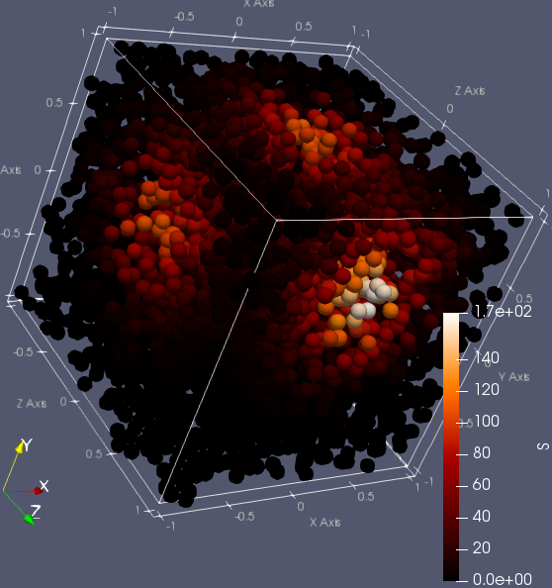

**Display the data using colored cutting planes**

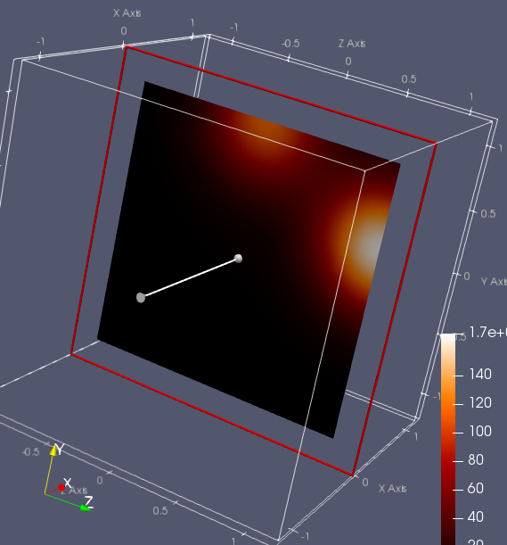

**Display the data using contour lines**

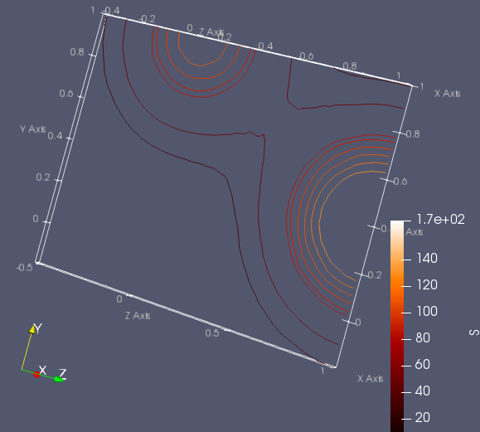

**Display the data using isosurfaces**

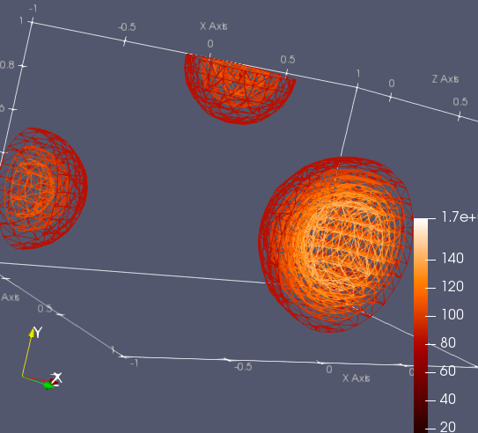

**Extra Credit:**

I’ve places my left and right images both here, ad was advised in class.

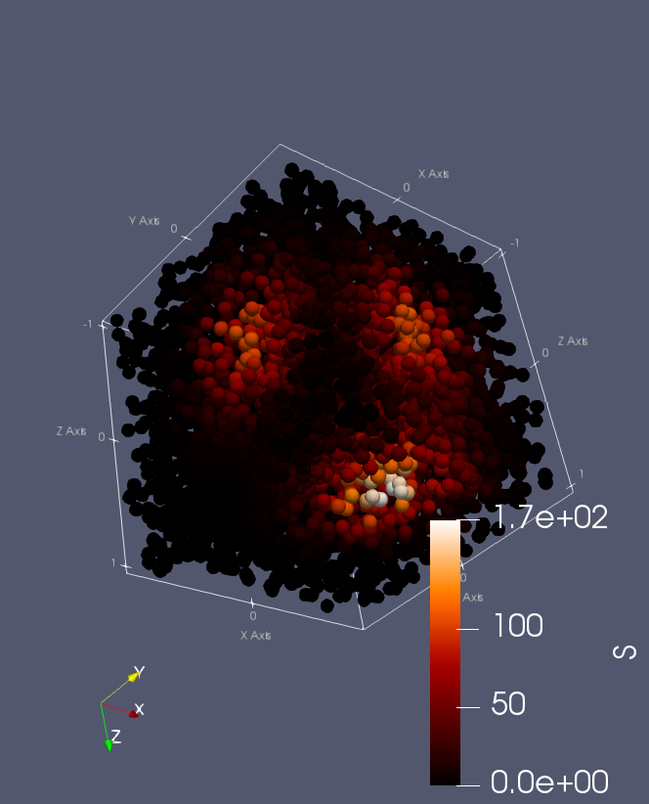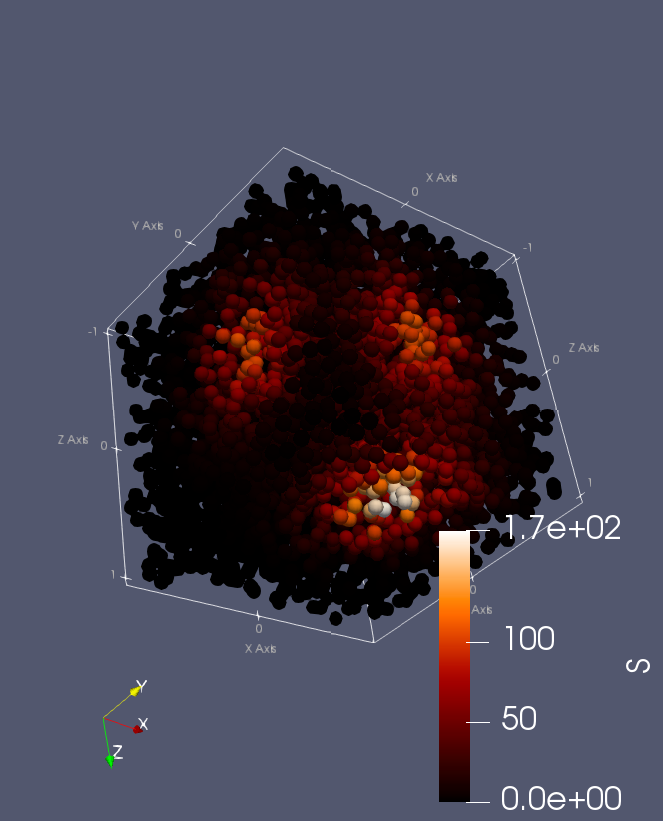

**Review:**

This was a good assignment to introduce the class to the basics of paraview, and how to display information using it, I really enjoyed the class demos on paraview, and the clear powerpoints on how to use it. Unfortunately, I am colorblind, and because of this I am unsure if my transfer function is a good representation of the dataset or not, Hopefully this is not an issue.